11/27/21

MET CS 767 Assignment 4T: GANs

*Nathan A. Horak*

Copy the implementation [here](https://colab.research.google.com/drive/129XTL5-89jk93Cr8UwZA1SSbKDB8fLe8?usp=sharing) to your Google drive. Systematically modify this code or data in four different ways, attempting to improve the output, and report the results, using this Word file as a template. You are free to combine changes but each of the sections below should contain at least one new change. If necessary, you can show changes that make the result worse, with your explanation. Please leave the gray text and the headings unchanged.

For voluminous material, consider using appendices. These are read on an as-needed basis.

# First Code Modification

## 1.1 Description of what I did and reason this *could reasonably be* an improvement (up to two paragraphs are recommended for this, excluding figures and tables)

GANs (Generative Adversarial Networks) are a powerful tool that allow neural networks to be used for tasks such as realistic image generation. According to TensorFlow Tutorials, GANs work when two models are trained simultaneously by an adversarial process. A generator learns to create images that look real, while a discriminator learns to spot real images amongst fakes[7] (See Appendix B & C). As the algorithm progresses through the training process, the generator becomes better at creating realistic images while the discriminator becomes better at identifying real images from fakes. The process reaches equilibrium when the discriminator can no longer distinguish real images from fake ones[7]. The given code artificially creates images based on the MNIST dataset (handwritten digits 0-9 from multiple individuals) utilizing a GAN. Here is the final frame of digit generation and a .gif of all the frames in subsequent order:

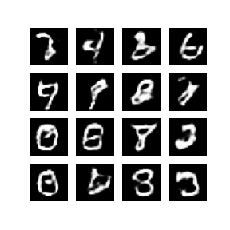

The .gif on the right shows the algorithm iterating through each epoch (currently, there are 50 epochs) and improving over time. The image on the left shows a reasonable result, with some generated images looking almost realistic while others still have a ways to go with regard to appearing real. In order to improve the end result of the code, I sought to make improvements. Per Jonathon Hui, deep networks may suffer from overconfidence- and a way to mitigate this issue is adding dropout[2]. Dropout adds noise to the images before feeding them into the discriminator model, according to the website. After closely examining the code that generates generator and discriminator objects, I noticed dropout instances with a hyperparameter of 0.30 in the discriminator creation function but not in the generator creation function. As such, I modified the generator function to include dropout instances with a hyperparameter of 0.30 following each LeakyReLU activation. I also noticed from the original code .gif that the images generated became more and more authentic going from the first to last epoch. I want to see if increasing the number of epochs, and thus increasing the time that the two models iterate and learn, would lead to a meaningful increase in image fidelity. As such, I increased the number of epochs from 50 to 80. I was curious if the aforementioned changes of adding dropout would lead to additional improvement iterating over 80 epochs instead of 50 (See Appendix A). Although I was wary of the increased running time from adding 30 more epochs, I was pleased with the result using 80 epochs compared to 50.

## 1.2 Comparison of the result with the original output, with explanation

GAN performance is not analyzed in the same way that the performance of other types of neural networks are. A machine learning engineer utilizing GANs to generate images is first and foremost interested in a realistic generated visual output. Per Jason Brownlee at machinelearningmastery.com, GAN models function differently given that they are trained with a second model (discriminator) rather than with a loss function until convergence[1]. The models are trained simultaneously to maintain an equilibrium. There is no objective loss function to train the GAN generator models and no way to objectively assess the progress of the training[1]. Instead, there are two main ways to assess the performance of a GAN used for image creation: through manual inspection of generated images or quantitative measures such as an inception score and Frechet inception distance. At the start of the process, it is reasonable to simply stick with manual inspection before adding in quantitative measures[1]. With this reasoning, below are the final frame of digit generation and a .gif of all the frames in subsequent order for the visual output used by the first code modification algorithm:

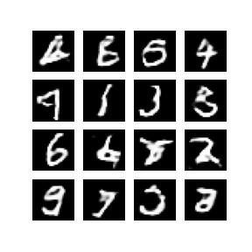

Examining these results, it seems as though there is a slight improvement with regard to clarity for the generated images when comparing to the generated images from the original code. In particular, the ‘4’ on the first row and ‘6’ on the third row look quite realistic. There are still a number of images that look awkward and fake, but less in number than in the image and .gif from Section 1.1. Moving forward, I will stick with only using manual examination as a method of determining effectiveness of the algorithm. Given the relative simplicity of the images from the input compared with generated images of a dog, person, or house bedroom, manual examination will be more than sufficient to gauge how well the model is creating images of handwritten numbers.

## 1.3 URL of your Colab code

<https://colab.research.google.com/drive/1Wk5ve2IkHvO4s64i5dOgCR65Uo3x_G-H#scrollTo=ZpSoa27wfgy4>

# Second Code Modification

## 2.1 Description of what I did and reason this *could reasonably be* an improvement (up to two paragraphs are recommended for this, excluding figures and tables)

After examining the visual results from my first code modification, I aimed to incorporate changes for the second code modification that produced a noticeable improvement to the resulting image. The resulting image did improve from the first modification, but I desired a more substantial improvement for the second modification. As mentioned in Section 1.2, the performance of a GAN is not measured the same way as a traditional deep or convoluted neural network. It is a good idea for a machine learning engineer to focus (at first) on the visual output of the algorithm and to evaluate the image themselves. I incorporated a change mentioned by Jason Brownlee of machinelearningmastery.com. According to Brownlee, it is beneficial to utilize batch normalization[1]. Batch normalization standardizes the activations from a prior layer to have a zero mean and single unit variance, stabilizing the training process. Per Brownlee, batch normalization can benefit the visual output when used in both the discriminator as well as the generator models (excluding the output of the generator and the input to the discriminator)[1]. The given code has batch normalization applied appropriately in the generator model code, but not in the discriminator model code. I altered the code to satisfy correct usage (according to machinelearningmastery.com) of batch normalization layers and see the resulting visual output.

Secondly, I aim to add more complexity to the model by expanding the layers within the respective models. I made changes to the discriminator given that I was already introducing batch normalization (see Appendix B for more on discriminators). According to Jonathon Hui of towardsdatascience.com, the discriminator tries to catch the generator’s best attempts to create a fake[2]. The discriminator model’s architecture shows it to be a CNN (convolutional neural network) and because of this, its performance can be improved in similar ways to any traditional CNN. Per machinelearningmastery.com, adding an additional layer can be a good way to improve the accuracy of a CNN[1]. To incorporate this into the model, I added an additional Conv2D layer of size 256 following the second Conv2D layer. After this addition, the discriminator now has 3 Conv2D layers with filter sizes 64, 128, and 256.

## 2.2 Comparison of the result with the original output, with explanation

As mentioned in Section 1.2, there are two methods to evaluate the performance of a GAN used for image generation and for this assignment, I will stick to manually examining the results. See below the final framed image and a .gif of all the frames in subsequent order for the visual output used by the second code modification algorithm:

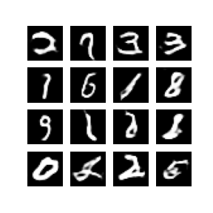

Comparing these results to the images from the first code modification, it seems that there is a reasonable improvement with regard to clarity and image authenticity. There is still more work to be done, however. Some digits still stick out, such as the extra thick ‘2’ and ‘0’ on the first and last row respectively as well as the apparent cursive ‘L’ on the last row. Lastly, the last third or half of the .gif shows little meaningful improvement of the images as the algorithm works. This could be a sign that there is more work to be done elsewhere in the architecture, but also that 80 epochs is simply too many and I overshot earlier. It’s possible that the addition of an additional Conv2D layer within the discriminator model has removed the need for additional epochs.

## 2.3 URL of your Colab code

<https://colab.research.google.com/drive/1Wk5ve2IkHvO4s64i5dOgCR65Uo3x_G-H#scrollTo=e2S1UJdEY-k5>

# The third way I modified the code to attempt improvement

## 3.1 Description of what I did and reason this *could reasonably be* an improvement (up to two paragraphs are recommended for this, excluding figures and tables)

For the third code modification changes, I want to alter the generator model just as I did in the first code modification (see more in Appendix C). I had added an additional Conv2D in the discriminator model (see Section 2.1) for the second code modification and I didn’t want to allow the discriminator to learn more efficiently relative to the generator. According to Syed Abdul of analyticsvidhya.com, the generator and discriminator work in tandem to create an image with each training to outdo the other[5]. As mentioned in Section 1.1 from TensorFlow tutorials, the GAN process reaches its equilibrium point when the discriminator can no longer distinguish real images from fakes[7]. The generator and discriminator models work off each other, and if I increase the complexity of one and not the other the equilibrium result will be a less optimal created image than it could have been otherwise. The first change I made that addressed this problem was adding an additional Conv2DTranspose layer. After the change, the generator model now goes from tensor sizes of (7,7,512), (7,7,256), (7,7,128), (14,14,64), to (28,28,1) with four Conv2DTranspose layers from (7,7,256), (7,7,128), (14,14,64) to (28,28,1) with three Conv2DTranspose layers. In addition, the filter size of the first Conv2D layer is now doubled from 256 to 512. Per machinelearningmastery.com, an increase in filter size is a good option to increase the performance of a CNN[1]. Given the structure of a Conv2DTranspose layer, increasing the filter size of one of these layers should allow for additional complexity and possible performance improvements (see Appendix D for more on Conv2DTranspose layers).

I want to make an additional change in this step and there was one parameter that I was interested in altering. When examining the .gif in Section 2.2 (associated with the second code modification) it seems as though the model sometimes hones in on creating crisp images that were not numbers and I want to address this. According to Tushar Mittal at medium.com, there are some possible consequences to having a large batch size[6]. Per Mittal, a bigger batch size might hurt performance because during initial training the discriminator might get a lot of examples to train on and it might overpower the generator. I decided to lower the batch size from the initial 256 to a lower number and settled on 64. In addition to being 256 divided by 2 twice, Mittal does mention this as a possible upper bound on batch size and I was curious if lowering the batch size had any positive effects. Lastly, I lowered the number of epochs. I think it was correct for me to increase the number of epochs for the first code modification. However, as mentioned in Section 2.2 I did notice not much change in the last half to third of the .gif from the second code modification. Given that the created images were not improving in the later section of the .gif as well as factoring the increased running time from the changes to the discriminator model in the second code modification and the changes to the generator in the third code modification, I reverted the number of epochs to 50.

## 3.2 Comparison of the result with the original output, with explanation

As mentioned previously in Sections 1.2 and 2.2, I am going to evaluate the GANs performance manually. See the final framed image and a .gif of all the frames in subsequent order for the visual output used by the third code modification algorithm below:

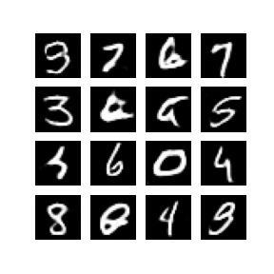

Examining this image output, there seems to have been a significant improvement comparing these results to the outputs from Section 2.2. Most of the numbers appear to be realistic but there are some notable exceptions- the wobbly ‘6’ on the first row and the two unidentified shapes in the second column of the second and fourth row. The decision to reduce the number of epochs back to the initial value of 50 seems to have not had any negative impacts, although the ‘9’ in the top left looks as though it is improving just before the .gif ends.

## 3.3 URL of your Colab code

<https://colab.research.google.com/drive/1Wk5ve2IkHvO4s64i5dOgCR65Uo3x_G-H#scrollTo=3gO5xlo1cNzN>

# The fourth way I modified the code to attempt improvement

## 4.1 Description of what I did and reason this *could reasonably be* an improvement (up to two paragraphs are recommended for this, excluding figures and tables)

For the fourth and last code modification, I had a few changes in mind. First, I explored altering the slope parameter associated with the ‘LeakyReLU’ activation method. According to the Keras API, ‘LeakyReLU’ is an activation method that allows for a small gradient when not active[8]. The default slope value when the unit is not active is 0.30 in Keras, as opposed to 0 for default ReLU. I want to lower the alpha (slope) value substantially to 0.01. I want the algorithm to focus on the differences between negative outputs and positive outputs, rather than on comparing negative values against other negative values. I would still somewhat maintain this ability by not abandoning ‘LeakyReLU’ completely for ReLU[8]. Despite the improvements in my code, there were still some instances of blurry images and I adjusted the activation method to try to remedy this. Secondly, I adjusted the noise vector. According to TensorFlow Tutorials, the images generated at the start of the process look like random noise and as the algorithm runs, the images adjust[7]. The given code has 100 as the size of the noise vector but I decided to increase its size. Increasing the size of the noise vector from 100 to 256, keeping with an exponent of base 2, would introduce more randomization into the generated images and give more for the generator and discriminator to work with (see Appendix C & D). According to Tushar Mittal of medium.com, altering the input noise is one way to improve the performance of a GAN[6]. Mittal mentioned 128 and 256 as possible sizes for the noise vector, and given that I want to use an exponent of base 2, those were my options as well. I opted for 256 as my noise dimension value given that 128 was not all that big of an increase from 100 and I was confident my algorithm could handle the substantially increased noise.

Lastly, I want to take a second look at the dropout instances I introduced in Section 1.1. Specifically, I want to examine whether the dropout parameter in the generator function should match the dropout parameter in the discriminator function. According to Jonathon Hui of towardsdatascience.com, dropout can help a model avoid overconfidence[2]. Dropping some of the input data can add random noise and allow the algorithm to perform better. From the first code modification on, I had the dropout parameter at 0.30 in both the generator and discriminator model. However, the risk of overconfidence is not equal between the generator and discriminator. Given the dynamic between the generator and discriminator where they work in tandem (addressed in Appendix C & D), if not enough noise is introduced in the generator model the discriminator model can figure out its counterpart too easily and push the GAN into equilibrium too early. Due to this, it seems that the dropout parameter should be higher for the generator model than the discriminator. According to Jason Brownlee at machinelearningmastery.com, a suggestion is to use a dropout parameter of 0.50 during train and generation[1]. As such, I settled on changing the dropout parameter of instances within the generator model to 0.50 while leaving the dropout parameter within the discriminator model at 0.30.

## 4.2 Comparison of the result with the original output, with explanation

As mentioned in previous comparison sections, I am going to manually evaluate the performance of the model for the fourth code modification. Below see the final epoch image and the .gif of all ordered frames of the visual output from the fourth code modification algorithm:

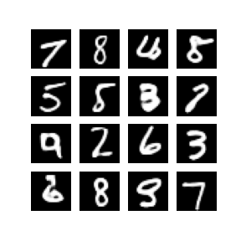

Examining the output, there is a lot to like. Many of the digits look real and there are only a few that look borderline or poor. A few that quite clearly stick out in a negative way are the first and fourth digits in the third column (looks like a very poor ‘4’ and disconnected ‘8’) and the fourth digit in the first column (an odd ‘6’). Most of the other digits look very good or pretty good, for example, the third row. All in all, I am quite pleased with the improvement from the original code to this output.

## 4.3 URL of your Colab code

<https://colab.research.google.com/drive/1Wk5ve2IkHvO4s64i5dOgCR65Uo3x_G-H#scrollTo=mkfZ-MCA5XSP>

# References

Show that you used a wide variety of resources by listing them below and clearly indicating in the body above where you used. Make sure to use proper referencing in your paper. We suggest using APA format, but other formats are fine as long as they clearly distinguish your work from work of others in your response. In general, observe the stated plagiarism rules.

[1] Brownlee, Jason. (2020, April 17). *Machine Learning Mastery*. machinelearningmastery.com. Retrieved November 27, 2021. [https://machinelearningmastery.com/](https://machinelearningmastery.com/convolutional-layers-for-deep-learning-neural-networks/)

[2] Hui, Jonathan. (2018, June 18). *GAN- Ways to improve GAN performance*. towardsdatascience.com. Retrieved November 27, 2021. <https://towardsdatascience.com/gan-ways-to-improve-gan-performance-acf37f9f59b>

[3] Shorten, Connor. (2018, September 26). *DCGANs (Deep Convolutional Generative Adversarial Networks)*. towardsdatascience.com. Retrieved November 27, 2021. <https://towardsdatascience.com/dcgans-deep-convolutional-generative-adversarial-networks-c7f392c2c8f8>

[4] Wei, Kuan. (2020, July 29). *Understand Transposed Convolutions*. towardsdatascience.com. Retrieved November 29, 2021. [https://towardsdatascience.com/understand-transposed-convolutions-and-build-your-own-transposed-convolution-layer-from-scratch-4f5d97b2967](https://towardsdatascience.com/understand-transposed-convolutions-and-build-your-own-transposed-convolution-layer-from-scratch-4f5d97b2967/)

[5] Abdul, Syed. (2021, July 7). *Deep Convolutional Generative Adversarial Network (DCGAN) for Beginners*. analyticsvidhya.com. Retrieved November 27, 2021. <https://www.analyticsvidhya.com/blog/2021/07/deep-convolutional-generative-adversarial-network-dcgan-for-beginners/>

[6] Mittal, Tushar. (2019, Aug 23). *Tips on Training Your GANs Faster and Achieve Better Results*. Retrieved November 27, 2021. <https://medium.com/intel-student-ambassadors/tips-on-training-your-gans-faster-and-achieve-better-results-9200354acaa5>

[7] *TensorFlow Tutorials*. tensorflow.org. Retrieved November 27, 2021. <https://www.tensorflow.org/tutorials/>

[8] *Keras API Reference*. keras.io/api. Retrieved November 29, 2021. <https://keras.io/api/>

# Appendix

[A]

<https://colab.research.google.com/drive/1Wk5ve2IkHvO4s64i5dOgCR65Uo3x_G-H#scrollTo=7LLfGk5lOuFy>

As mentioned in Section 1.1, I explored whether increasing the number of epochs would lead to a better end result when incorporating in the addition of dropoff layers within the generator function. My basis for this was what I saw- when observing the .gif of image outputs per epoch, the generated images become clearer and more realistic over successive epochs. I did have my concerns, though. Per Tushar Mittal of medium.com, overtraining might hurt a GANs performance[6]. Overtraining might degrade the quality of the generated samples and according to Mittal, most contestants in a Kaggle contest to train a GAN on the Stanford Dogs dataset to create new images of dogs reported that their best images were produced in the middle of training loops rather than at the end[6]. With this, below are the final frame of digit generation and .gif of showing the generated visual output by the code with 50 epochs and then with 80 epochs:

*Last generated image and .gif with 50 epochs:*

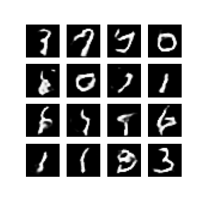

*Last generated image and .gif with 80 epochs:*



Comparing these, it seems as though the generated images with 80 epochs look slightly more realistic than the images created using 50 epochs. The generated images from 50 epochs contain multiple renditions that look nothing like digits, including what looks like a ‘y’ on the first row. The generated images for 80 epochs only contain a few digits that look like a real number, but there are more than from the first image. Furthermore, the digits that look fake look more realistic than the non-realistic digits from the first image. Given this, I will use 80 epochs instead of 50 for iterations at this time.

[B]

Discriminators are one of the two models that a GAN uses to generate images. Per the TensorFlow tutorials, a discriminator is an image based CNN classifier that determines whether input images are real (from the original data set) or fake (created by generator)[7]. While training, the generator creates better fake images and attempts to fool the discriminator that the generated image is real while the discriminator tries to become better at detecting and classifying whether the image is real or fake, according to Syed Abdul of Analytics Vidhya[5].

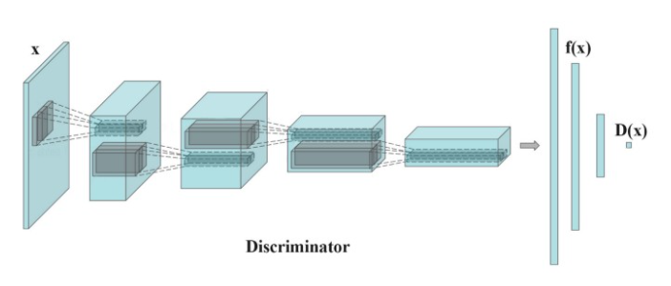

*Visual representation of Discriminator model, per Jonathon Hui of towardsdatascience.com[2].*

[C]

Generators are one of the models that make up a GAN. The generator takes input points from a latent space and generates an image, per machinelearningmastery.com[1]. According to the TensorFlow tutorials, the generator utilizes Conv2DTranspose (upsampling) layers to produce an image from a random noise seed[7]. The dense layer takes this seed as input and samples it several times until the desired image size of 28x28x1 is reached. The layers all use ‘LeakyReLU’ activation except the last layer, which uses a ‘tanh’ activation.

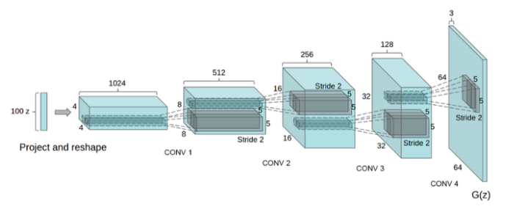

*Visual representation of Generator model, per Connor Shorten of towardsdatascience.com[3].*

From Connor Shorten of towardsdatascience.com, the generator network takes random noise and maps it into images in order to trick the discriminator (discussed in Appendix C)[3].

[D]

Transposed convolution layer, written in code as Conv2DTranspose, is one of the two ways the generator model can function as needed for a GAN to operate correctly. Per Tushar Mittal of medium.com, either upsampling layers or the aforementioned transposed convolutions layers are required for a generator network[6]. According to the Keras API, Conv2DTranspose layers are used when a Conv2D transformation needs to occur in the opposite direction from a normal convolution to match a specific output[8]. Unlike MaxPooling that can cause some data to be lost, a Conv2DTranspose layer maintains a connectivity pattern compatible with associated convolution[8]. According to Kuan Wei of towardsdatascience.com, a transposed convolution is the opposite of a convolution[4]. A smaller matrix of data can be transformed into a larger matrix by multiplying each data point by an associated kernel.

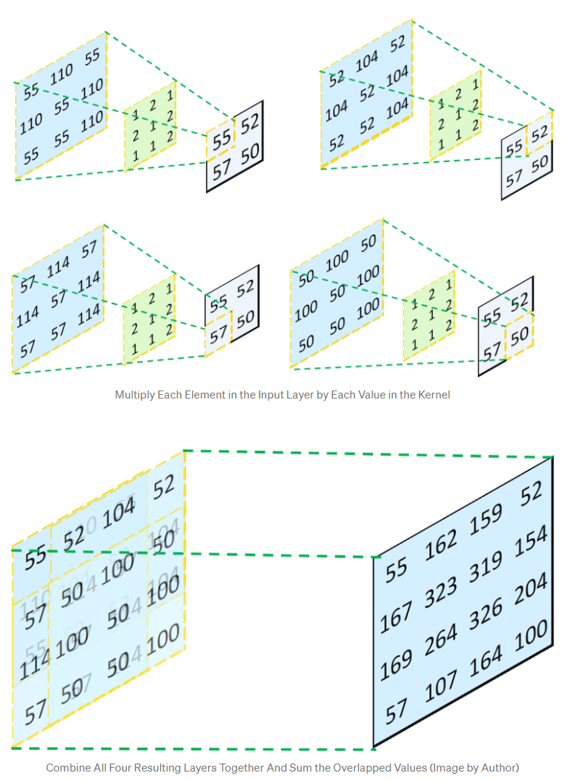

*Visual representation of Conv2DTranspose layer,, per Kuan Wei of towardsdatascience.com[4].*

It is always certain that the output of the transposed convolution operation can have the exact same shape as the input of the previous convolution operation, because we just performed the action in reverse[4]. However, as the numbers are not restored, a different kernel has to be used to restore the initial input matrix, and this kernel can be iterated on during training, according to Wei.

# Evaluation

